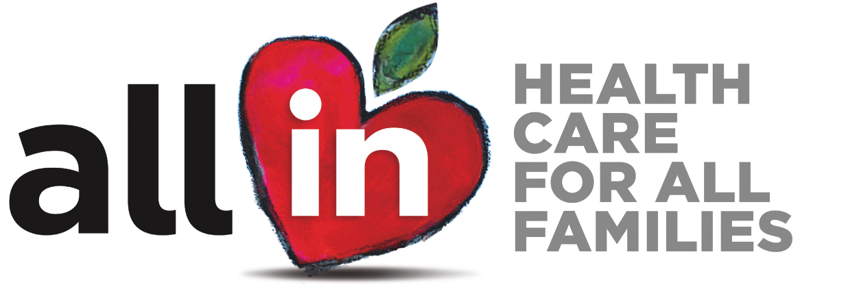

School Blurb for Newsletters, Social Media,
Letters, & Other Channels That Reach Parent & Families

ALL IN Materials

Subject: ALL KIDS Can Get the Care They Need

ALL income-eligible kids, regardless of immigration status, qualify for full-scope Medi-Cal. This means that undocumented children will be able to get the full array of preventive and treatment-related health care that they were previously ineligible for because of their immigration status. Enroll your children in full-scope Medi-Cal today to get them needed care. Medi-Cal is either no or low cost, depending on family income.

(Insert ABCs Flyer)

Once kids have coverage they should get the care they need! Here are four simple steps to get preventive care when your kids have health insurance: 1) Choose a provider 2) Make appointments for annual checkups 3) Seek help when your child needs it, and 4) Keep your kids’ health records handy.

(Insert Get Care Flyer or Card)

TCP Dental Flyers

Subject: A Reason to Smile
If your children are enrolled in health coverage through Medi-Cal or Covered California, they also have comprehensive dental coverage! This means they can get preventive dental services—such as exams, cleanings, and more—and treatment for problems like fillings and other dental services.

(Insert dental fact sheet)

INSERT YOUR SCHOOL NAME/DISTRICT is part of the ALL IN For Health Campaign, which provides information about affordable health coverage opportunities and can connect you with people who can help you and your family enroll. For more information, visit www.allinforhealth.org or ask your INSERT SCHOOL CONTACT INFO.

